Boardman Ohio Storm Sewer Evaluation

2023 CCTV of storm sewers on Pierce Drive and east of Yakata Dora Drive

List of sewer segments CCTVed

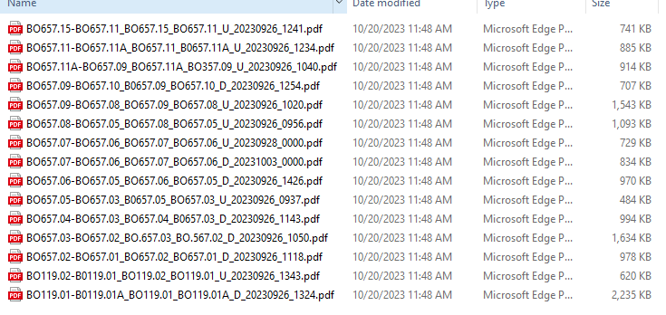

01

02

03

04

05

06

07

08

09

10

11

12

13

14

15

Recommendations

1. 18” RCP - Clean and re CCTV in 10 years
2. 15” RCP - Clean and re CCTV in 10 years to see if fractures are deteriorating
3. 15” RCP - Clean and re CCTV in 10 years to see if fractures are deteriorating
4. 15” RCP - Clean and re CCTV in 10 years– CB at end ?
5. 15” RCP - Clean and re CCTV in 10 years to see if fracture and joints are deteriorating
6. 18” RCP - Clean and re CCTV in 10 years to see if joints are deteriorating
7. 8” VCP w/PVC repair – replace to remove sag and bends
8. 8” VCP w/PVC repair – Clean and re CCTV in 10 years to see if fracture, bulge and joints are deteriorating
9. 10” RPM - Clean and re CCTV in 10 years to see if pipe is deteriorating
10. 18” RCP - Clean and re CCTV in 10 years
11. 12” VCP and PVC – Clean and re CCTV in 10 years
12. 21” RCP - Clean and re CCTV in 10 years to see if fractures are deteriorating
13. 21” RCP - Clean and re CCTV in 10 years
14. 18” RCP - Clean and re CCTV in 10 years
15. 18” RCP and 20 L.F. of CMP - Clean first 204 feet of RCP. Repair last 20 feet of CMP
    1. Block the void under the CMP at the outfall.
    2. Fill the eroded bottom of pipe with LSM in preparation for lining
    3. CIPP the CMP after the LSM has set up.
    4. CCTV in 10 years to see if fractures are deteriorating

F:\ABC\Boardman\2023 CCTV Pierce Dr .Docx

\\Ctc.Local\CT_Data\Projects\2023\231360\PHASE\1 Preliminary Engineering\Video\2023 CCTV Pierce Dr Review.Docx